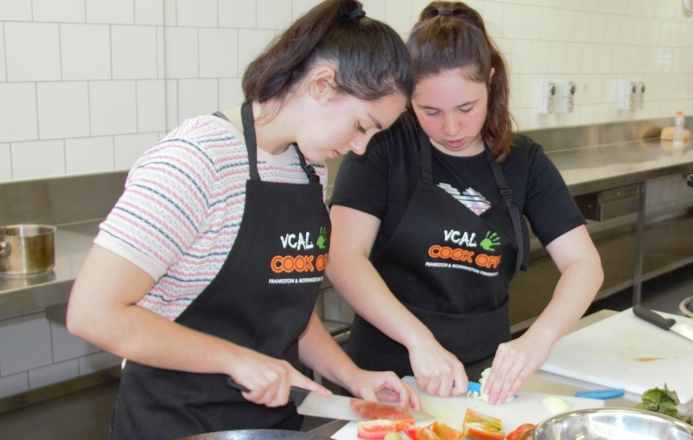
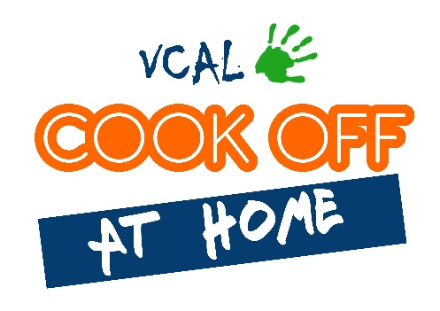

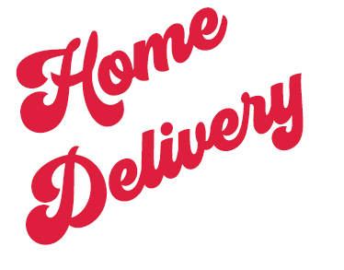
WELCOME TO THE 2020
FRANKSTON MORNINGTON PENINSULA VCAL COOK OFF!
Because of the COVID-19 restrictions we are unable to host the competition with teams face to face this year. Instead we are bringing the event to you at home.
So crank up the heat, get creative in your kitchen and show us your best dish for a chance to win some great prizes.
To find out more watch this short video:
COOK OFF FROM HOME 2020

HOW TO COMPETE - IN 5 EASY STEPS
- Join our Facebook Group – Cook Off at Home 2020.
- Select or create your own recipe.
- Get cooking using ingredients found at home!
COOK OFF
AT HOME
2020
HINTS AND TIPS!
INTERVIEWS!
RECIPE INSPIRATION!
EPIC FAILS!
- Take a photo of your preparation and finished dish.
- Email your entry to us!
SUBMITTING YOUR ENTRY
To be eligible to win, you need to email us the following:
- Completed Entry Form
- Photo of your preparation
- Photo of your finished dish
- Copy of your recipe
Email your entry to jo@fmpllen.com.au
Entries close 20th October 2020
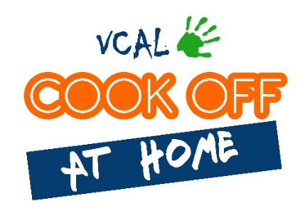
ENTRY FORM

YOUR DETAILS
STUDENT NAME | Click or tap here to enter text.
SCHOOL | Click or tap here to enter text.
EMAIL ADDRESS | Click or tap here to enter text.
MOBILE | Click or tap here to enter text.
DETAILS ABOUT YOUR DISH
NAME OF DISH | Click or tap here to enter text.
IS THIS YOUR OWN RECIPE?  (Did you invent this dish?) | Please tick:  YES ☐ NO ☐
COMPETITION CATEGORY | Please tick:  Entrée ☐ Main Course☐ Dessert ☐
TELL US A BIT ABOUT YOUR DISH  EG: Why did you choose this dish? Is it special to you? Does it have any particular ingredients, type of cuisine? | Click or tap here to enter text.
HOW TO ENTER
Email your entry to jo@fmpllen.com.au by 20th October 2020.
To be eligible, you must include the following:
Please tick to make sure you have all the elements ready to email
☐ This completed entry form
☐ Photo of your finished dish
☐ Photo of your preparation
(this can be any part of the preparation or laid out ingredients etc)
☐ Copy of your recipe
PHOTO PERMISSION AND DECLARATION: By submitting this entry, I give permission for the photo of dish, my first name and school to be posted online through the FMPLLEN’s website and social media channels. By submitting this entry, I declare this dish was cooked by me.
Please make sure you practise safe food handling and take care when using kitchen equipment when preparing your dish at home. The FMPLLEN takes no responsibility for loss, injury or damage.

